Pitch or roll over? Fixed wing aircraft turn and pitch dynamics

Table of Contents
Introduction 1
Basics 1
Mathematical description 6
Balanced co-ordinated turn in level flight 6
Co-ordinated turn during pitch adjustment 7
Definitions 8

Introduction

Basics

In level flight, lift generated by the wing equals mass* gravity

Drawing 1: Level flight

When banked in a moderate balanced turn, more lift needs to be generated by the wing. A component of the wing lift is directed sideways which accelerates the aircraft around the turn.

In a flat turn, the elevator mostly influences the earth based pitch and not the earth based rotation. Rolling the aircraft slightly does not greatly influence the turn rate or pitch rate.
Drawing 2: Flat turn

During a moderate turn, roll angle and elevator control contributes to both pitch and yaw. Rudder also contributes to both. In a normal co-ordinated turn, rudder needs to be applied to avoid slip which increases drag. The ideal turn has no component of acceleration in the span axis of the aircraft.

Drawing 3: Moderate turn

In a steep balanced turn the lift generated by the wing is much larger than the lift required against gravity. Elevator has very little influence on earth based pitch. Most aircraft do not have enough control authority on the rudder to change pitch. Using the rudder and body lift to influence pitch causes more drag than using lift wing so it should be avoided.
Drawing 4: Steep turn
To control pitch, the aircraft must roll slightly to change the direction of the lift it is generating. The result is an increase/decrease of pitch but a corresponding decrease/increase of turn rate. To keep a constant turn rate, the lift force (elevator) must be changed.

Drawing 5: Altered roll angle for pitch control
This leads to some questions:
- What happens when the limits of lift are reached, either by maximum airframe stress or by stall limit?
- Should turn rate be kept constant as the roll position is modified?
- Some aggressive turns demand that that the aircraft turns through inverted. What happens when the aircraft is inverted?
- If the aircraft is moved from desired roll position by turbulence or control error, what should the response be?
- What happens when the aircraft is at a moderate to steep pitch angle.

Mathematical description

Balanced co-ordinated turn in level flight
Calculating the expected pitch and yaw rates in a balanced and co-ordinated turn. Input is the roll angle to vertical.

In a balanced turn where there is zero earth pitch:

Where:
Fg = force due to gravity
Drawing 6: Forces in a balanced co-ordinated turn
Fg=m*g
Ft=m*g*tanΦ
Fl=m*g/cosΦ
Φ
Fl = Lifting force
Ft = Resulting tangential force from lift

There will also be a small force from the rudder in a co-ordinated turn but that will be dismissed for now.

The tangential force causes acceleration around a turn. The acceleration is:
V''t = Ft / m = g*tanΦ

and the earth based vertical axis rotation rate is:

γ' = V''t / Vf
where:
Vf is forward velocity
γ' is the rate of earth heading change

This turn is a rotation which will be measured by both pitch and yaw gyros in varying ratio depending on the roll angle.

q = γ' * sinΦ
r = γ' * cosΦ
where q is aircraft pitch rate and r is the aircraft yaw rate.

Co-ordinated turn during pitch adjustment
In this case, the aircraft rotates away from its balanced turn to make a pitch adjustment. Inputs are the required turn rate and the required pitch rate. Outputs are desired roll angle, desired aircraft pitch rate and .

Drawing 7: Forces during pitch adjustment
Ft
Fln
Fla
Fpa
Φ
Φm
Fpa is the total lift required for the pitch adjustment and gravity
Fp = Fpa - Fg
where Fp is the force required for pitch acceleration.

q = Fp /(m * Vf)
q is pitch rate
Vf is forward velocity
m is mass

rearranging: Fp = q * m * Vf
Fpa = m * ( (q * Vf) + g)

Fla = (Fpa² + Ft²)^{0.5}

Φm = arctan(Ft/Fpa) = arctan( ((q*Vf)+g) / g )

Turn during large pitch

Defining aircraft heading
To understand how to control, we need to decide which way we are going and what to do about it.

Introducing the miniature personal jet in level flight. The arrow indicates the direction of heading.

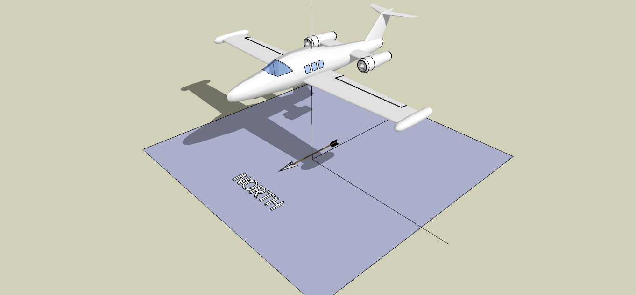Figure 1: Level flight
Now say the aircraft pitches aggressively. We still understand what the direction of travel is.

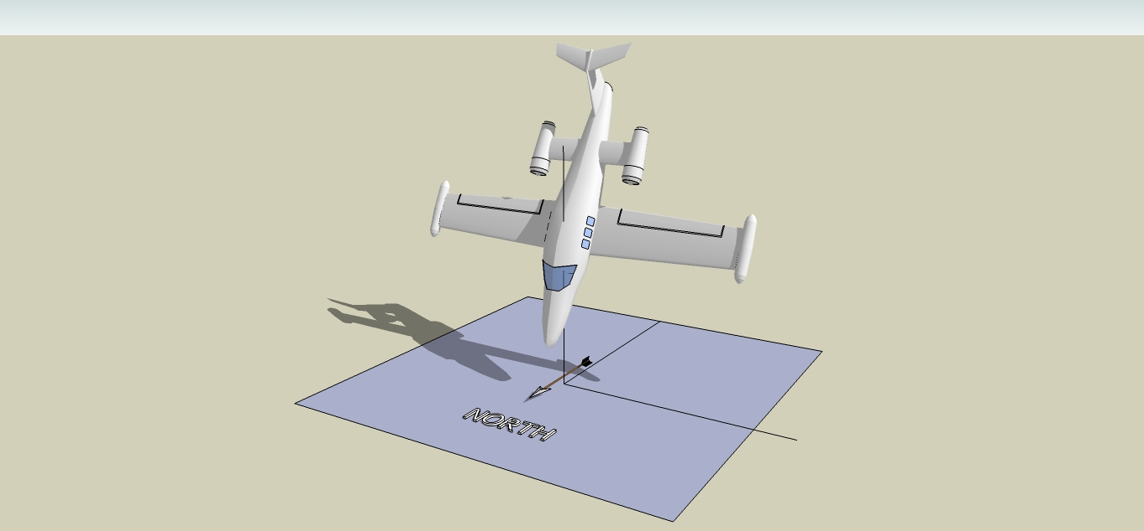Figure 2: Steep pitch down

Figure 3 Shows what happens at steep pitch and steep roll. The aircraft heading has changed.
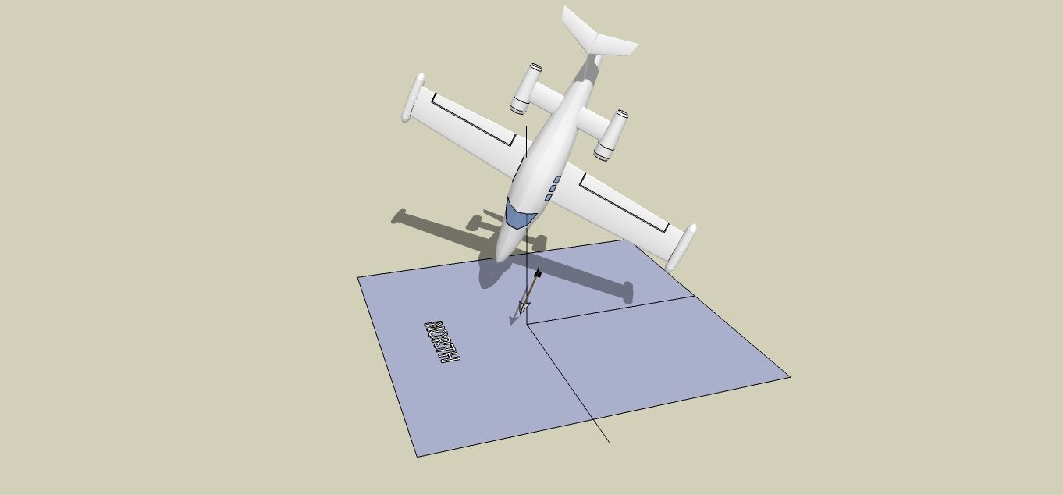Figure 3: Steep pitch and steep roll
Figure 4 Shows what happens when adding a little yaw to steep pitch. The position is the same as combined roll and pitch.

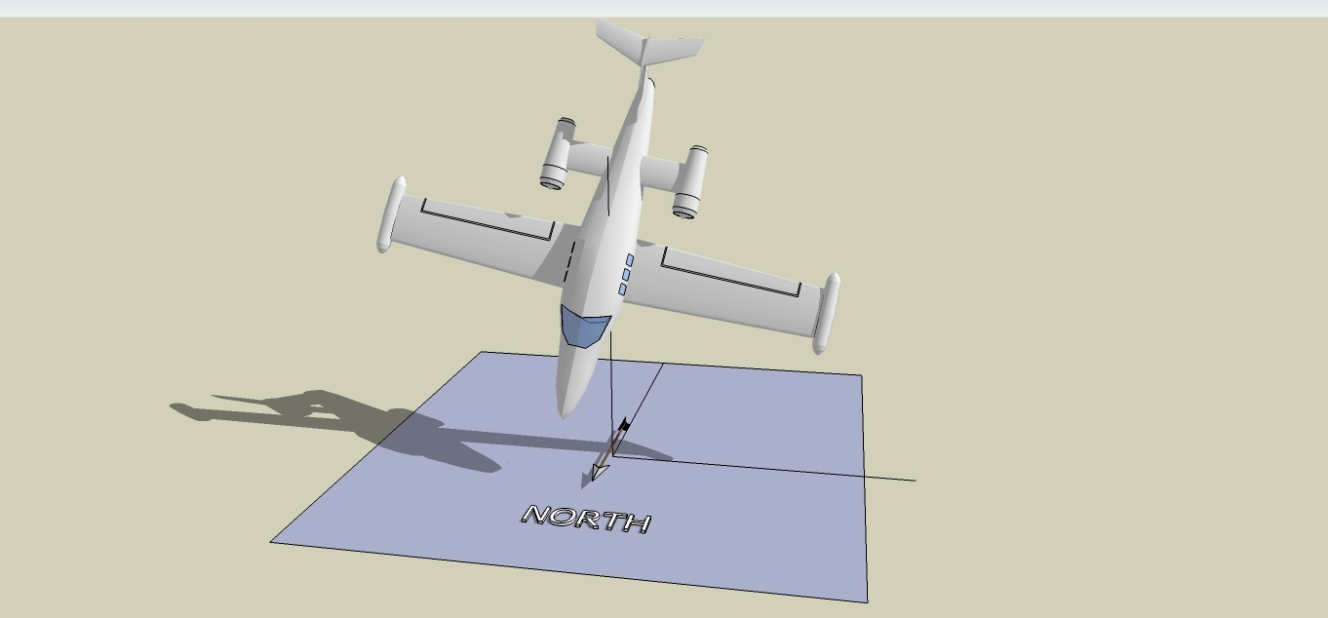Figure 4: Large pitch with yaw

In level flight, heading is dominated by aircraft yaw. In steep pitch, aircraft heading is dominated by aircraft roll. In steep roll, heading is dominated by aircraft pitch.

Say the aircraft is part rolled and part pitched. What should the heading be calculated as? What should the expected rotation rates be?

What happens when the aircraft is steep pitched but inverted? In the example shown by Figure 5, the useful aircraft heading might be to the front, even if the actual flight path is to the back. This bias is caused by the aircraft being able to pitch up harder than pitch down. There are exceptions with symmetrical acrobatic aircraft that we need to consider.

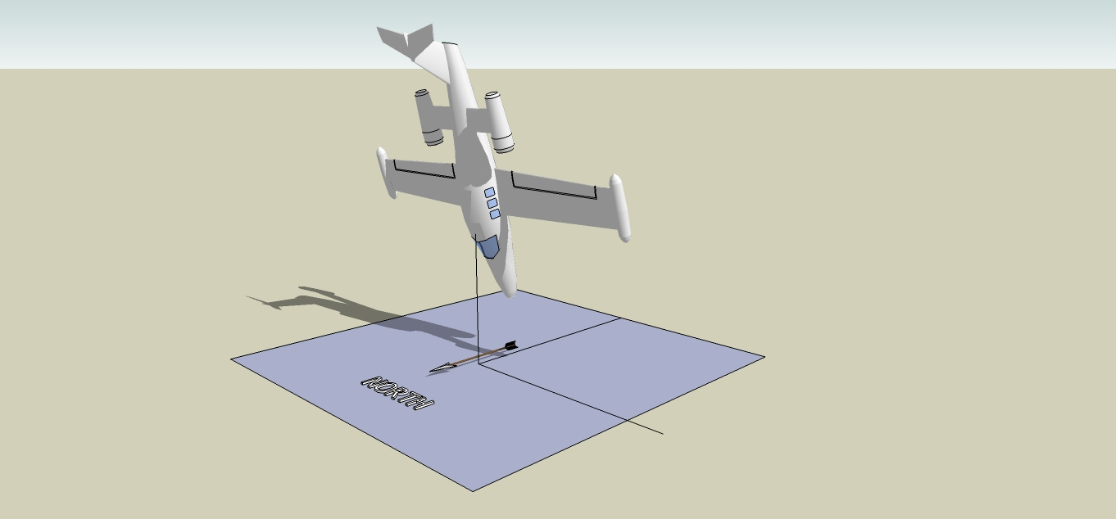Figure 5: Steep pitch inverted
There are manoeuvres that use this aircraft position such as the Immelman turn. In this case, the aircraft should not enter inverted stabilisation and should continue to complete the half loop.

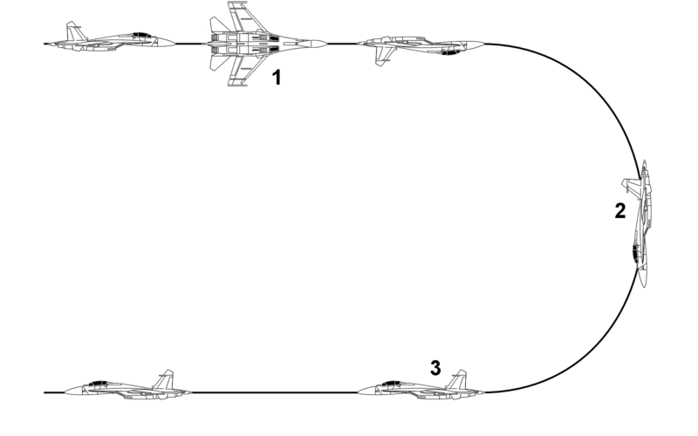Figure 6: Immelman turn

There is always a special case where we get confused trying to express heading in terms of earth based yaw. It is better to use heading based on both yaw and pitch. The result can be an angle of desired rotation required to meet the desired heading requirement. Depending on priorities and flying style, different rotation and pitch will be performed but the direction of travel and rotation towards desired direction will always be understood.

Forces in a pitched turn

Flight priority and flying style

Flight priorities
- Altitude priority
- Airspeed priority
- Airframe priority
- Stall priority
- Heading priority
- Turn rate priority
- Throttle priority

Flying styles
- Speed
- Cruise
- Minimum energy
- Acrobatic

Dynamics in a loop

This is relevant to aggressive turns combined with airspeed limits and/or maximum g limits.

Loops can be performed with different priority depending on requirement:
- Perfect circle
- Maximum rotation
- Constant rotation

A vertical manoeuvre has an energy gain/loss associated with it. Each type has different hight los

Assuming a constant rotation rate

Definitions
Forces and Moments
Quantity | Variable | Dimensionless Coefficient | Positive Direction
Lift | L | CL = L/qS | 'Up' normal to freestream
Drag | D | CD = D/qS | Downstream
Sideforce | Y | CY = Y/qS | Right, looking forward
Roll | l | Cl = l / qSb | Right wing down
Pitch | M | Cm = M/qSc | Nose up
Yaw | N | Cn = N/qSb | Nose right

Angles and Rates
Quantity | Symbol | Positive Direction
Angle of attack | α | Nose up w.r.t. freestream
Angle of sideslip | β | Nose left
Pitch angle | Θ | Nose up
Yaw angle | Ψ | Nose right
Bank angle | Φ | Right wing down
Roll rate | p | Right wing down
Pitch rate | q | Nose up
Yaw rate | r | Nose Right
Earth heading | γ | Nose right

